EXP.NO: 02 | VI Editor & Nano

AIM:

To understand the usage of Vi Editor and Nano Editor for creating and editing files in Linux.

ALGORITHM:
• Start the experiment.
• Open the Linux terminal.
• Create or open a file using vi filename.txt.
• Press i to enter insert mode.
• Type the required content in the file.
• Press Esc to exit insert mode.
• Type :wq to save and exit the file.
• Open the same file using nano filename.txt.
• Edit the content directly in Nano editor.
• Press Ctrl + O to save the file.
• Press Ctrl + X to exit Nano editor.
• Stop the experiment.

CODE:

VI Editor (Visual Editor) vi filename
open file in vi editor
Esc → i
insert mode
Esc → :wq
save and quit
Esc → :q!
quit without saving
Esc → o
insert in next line

Esc → Shift + o
insert in previous line
Esc → Shift + i
insert at start of line
Esc → Shift + a
insert at end of line

x
delete a character

r
replace a character

u
undo

:e!
undo all changes
Ctrl + r
redo

dd
delete one line

15dd
delete 15 lines

p
paste after line
Shift + p
paste before line
Shift + v
select whole line

v
select characters

y
copy

Search
Esc : /word
search from top, press n for next match

Esc : ?word
search from bottom, press n for previous match

Replace
Esc :%s/current/new/g
replace all occurrences in file

Esc :1 s/current/new/g
replace all occurrences in first line

Esc :1 s/current/new/1
replace first occurrence in first line

Esc :2,4 s/current/new/g
replace from line 2 to 4
Esc :2,$ s/current/new/g
replace from line 2 to end of file

Line Numbers
Esc :set nu - show line numbers
Esc :set nonu - remove line numbers

SED (Stream Editor)
used to modify files without opening them

Sed stream editor command

-n line specific output

-e multiple expressions

S substitute

g global

d delete

p print

Print Operations sed -n '3p' data
print 3rd line
sed -n '$p' data
print last line

sed -n '3,5p' data
print 3rd to 5th line

sed -n '/INDIA/p' data
print lines containing INDIA

sed -n -e '2p' -e '4p' data
print 2nd and 4th line

Replace Operations sed 's/old/new/g' data
replace old with new (display only)

sed -i 's/old/new/g' data
replace old with new in original file

sed '4s/old/new/g' data
replace in 4th line only

sed '2,6s/old/new/g' data
replace from line 2 to 6
sed '$s/old/new/g' data
replace only in last line

Delete Operations
sed '4d' data
delete 4th line
sed '$d' data
delete last line

sed '2,6d' data
delete line 2 to 6

sed '1d;3d' data
delete 1st and 3rd line

NANO Editor
sudo apt-get update -y ss sudo apt-get install nano -y
install nano editor

nano demo
open file in nano
Ctrl + o
save file
Ctrl + x
exit editor
Ctrl + k
cut line
Ctrl + u
paste line
Alt + u
undo
Alt + e
redo
Ctrl + w
search

OUTPUT:

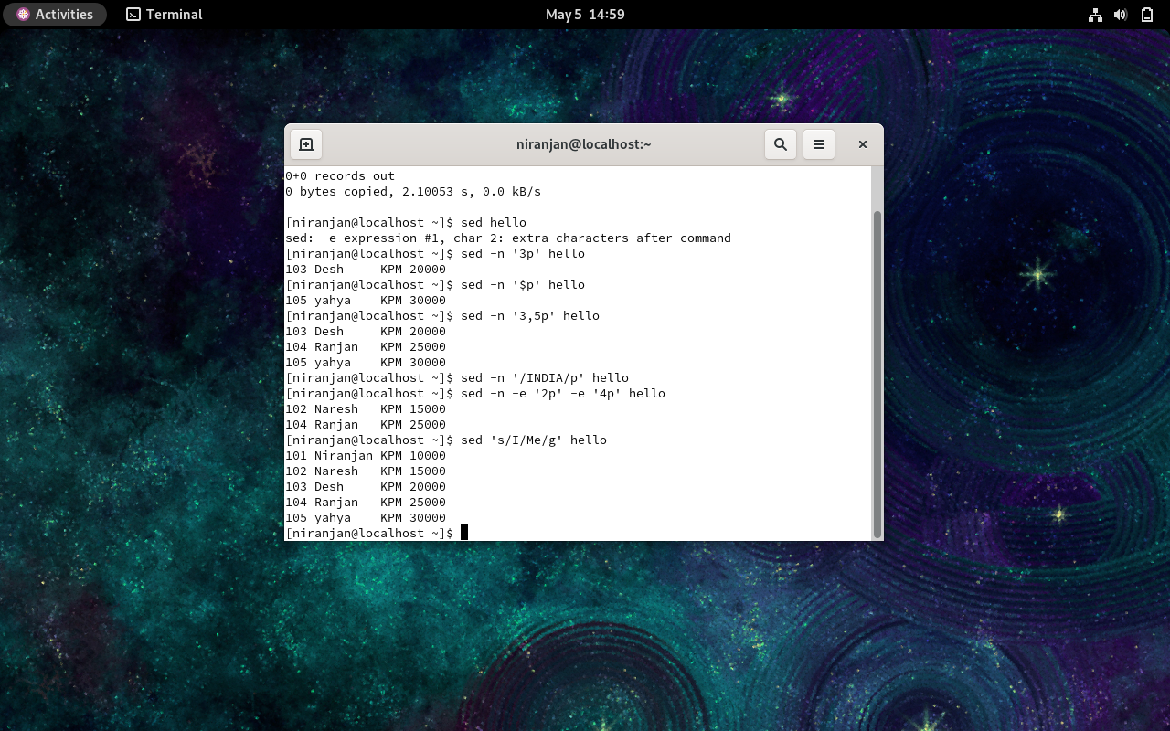

RESULT:
Thus, the basic Unix/Linux commands for directory navigation, file creation, viewing, copying, renaming, and deletion were successfully executed on the Oracle Linux system using the terminal.

